NWEA Testing – For Classroom Teachers
Update: April, 2021

To Log into NWEA
From District Webpage > For Staff > Quick Links > NWEA
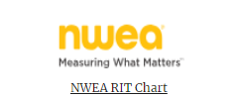

Remember….
NWEA Tutorials:
In the lower left corner of the Information Center area, click on Video Tutorials:
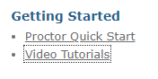
Scroll to….
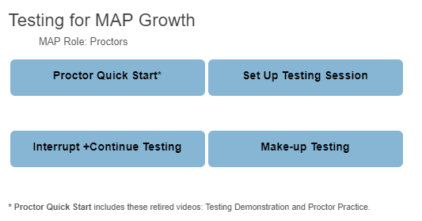

Practice Tests – on the NWEA Home Page – at the bottom
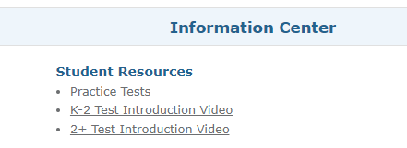
Or for students - within the secure browser or at test.mapnwea.org….
Good for demonstration or student practice.
*Try the Practice Test: User Name/Password: grow/grow
**Good for 1st Grade!! (shows speakers)
*Student Resources allows you to demonstrate tools.
**First graders need headphones!**
Student Access to NWEA (If remote, students go to test.mapnwea.org See last page for remote testing information.)
**In class students go to NWEA Lockdown Browser (All other programs on the computer need to be closed.)
Lockdown Browser on Devices:
On Macs – Log-in with Classroom/Classroom * Lockdown Browser may be in Launch Pad (Rocket)
iPads – MAP App must be installed on student iPads
Chromebooks – In the lower left corner, click on “Apps”. You’ll see an icon for the NWEA browser. (Make sure no one is logged in!!)
Teacher Access to NWEA
**Teachers log in at the NWEA website (From Staff Quick Links page on the OUSD website)
**Teachers: Log into NWEA – Manage Test Sessions > Test My Class
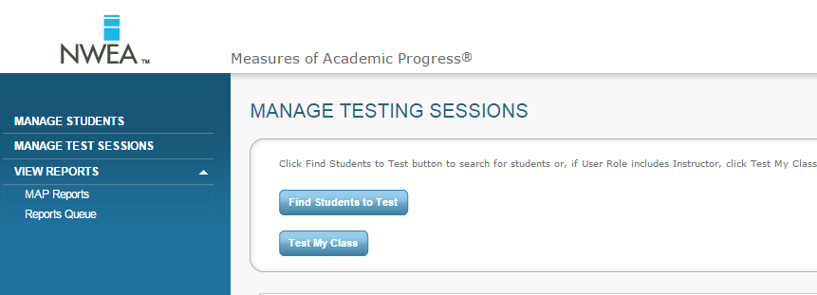
TESTING TIPS for Map Growth
Rapid-Guessing Alerts
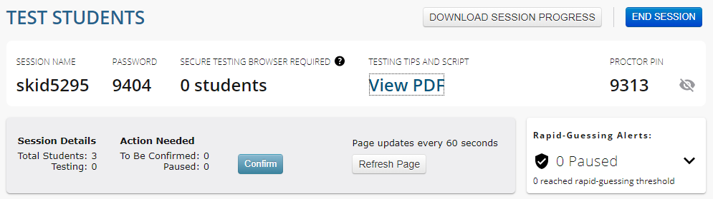
Students will receive an alert (Sloth!) if they reach the Rapid-Guessing threshold. You talk to them and give them your Proctor Pin.

Select Status > All > Assign Test(s) – be careful if you have a combo!
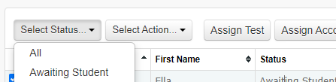

Tests to Administer – Growth (Not Screening)
Grades | Reading | Math | Language (optional)
1 | Reading K-2 | Math K-2 | N/A
2-5 | Reading 2-5 | Math 2-5 | Language
6-8 | Reading 6+ | Math 6+ | Language

(There is a Spanish test – might want to try it for students who have no English.)

You can add a student (maybe from another class) to your session
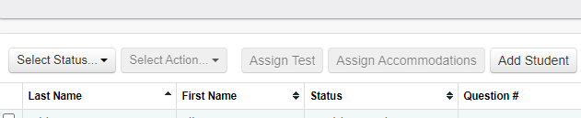

Accommodations

Teachers may add the Text to Speech accommodation ONLY FOR STUDENTS WHO HAVE THIS ACCOMMODATION ON THEIR IEP OR 504 PLAN. (Carefully consider using accommodations – or not.)

After you have assigned the tests, choose the student(s) click on Assignment Accommodations
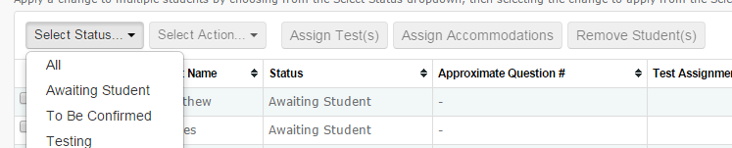
Then scroll down to find Text-to-speech. (Talk to your Special Ed teacher about which of the areas below are addressed in the IEP.)
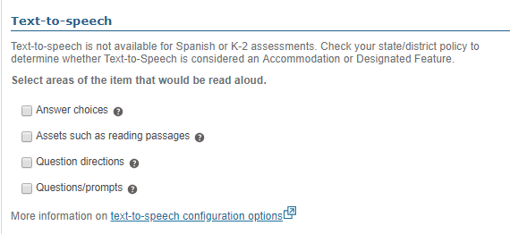
And then click 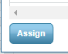at the bottom of the window.

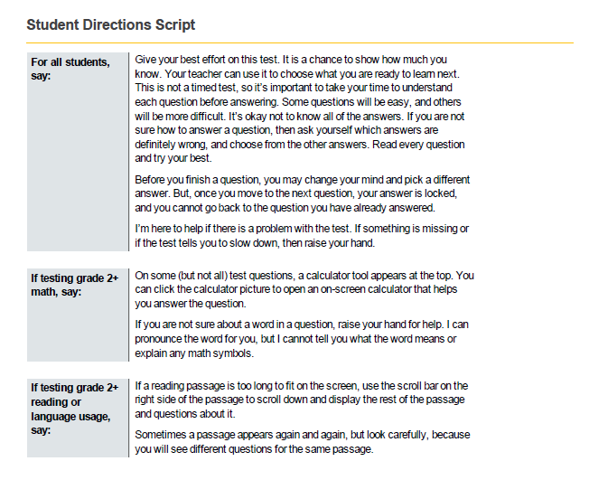

Give students Test Session Name and Password: (example below)
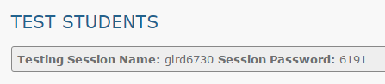
Students type their name as usual within the Lockdown Browser.
Teacher: Confirm Students:
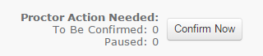
Teacher: End Test Session:
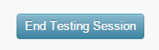
Hints:
*You can only have ONE test session open at a time.
*Pause (less than 30 mins.) > Resume (Return to the same machine.)
*Suspend (more than 30 mins.) > Test Again (Can move to another machine.) When the student logs in, the teacher will be asked if the student should start from the beginning or where he/she left off.
*Do not click on “terminate.”
***If the student doesn’t see his/her name, choose “Do Not Confirm” and have the student restart the browser and see if the name appears.
*White Screen/Frozen Screen: (on the student computer…)
PC – F5
Mac – Command + R
Or on Proctor Computer: Suspend > Test Again
May need “Shift + Alt + K” to close out of the secure browser on a Chromebook.
*Chromebook – Resolution Error – Control + Shift + 0
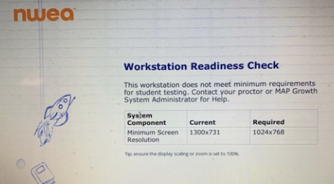
*Chromebook – Drag and Drop Problem – Click on what you want to move and then click where you want to move it. Don’t drag.

*Make Up Testing
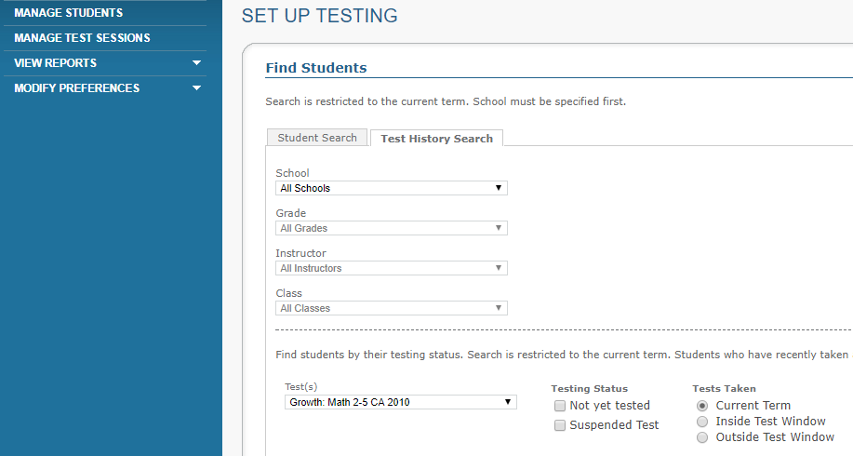

Information for Proctors who do not have their own class. Or if you are doing make-ups and want to check….
You will go to Manage Test Sessions > Find Students to Test
Then find the School, Instructor….
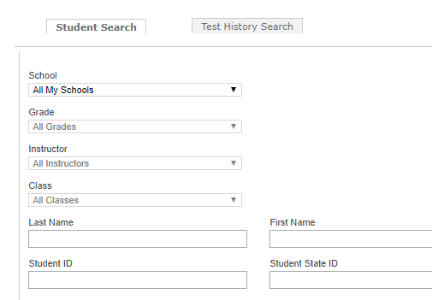
Once you have the session set up, you can save it at the bottom of the screen:
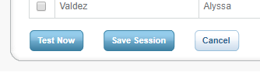
When you return, you can find your saved test session.
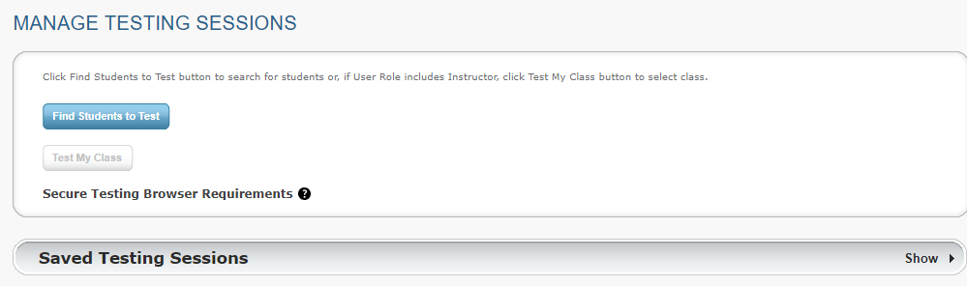

To have students take an additional test within a testing session, click “Test Again” and assign a new test.
If you need assistance, contact technology @orcutt-schools.net or the following tech numbers: 805 938-8976 or 805 938-8944.

Remote NWEA Testing
Student URL: test.mapnwea.org (Not a secure browser – students can have a Zoom window open AND the testing window open.)
Teacher starts a Zoom Meeting to instruct the students. Teacher starts a test session as usual. Teacher gives students Session Name and Session Password. Teacher stays on Zoom to monitor students and to answer any student questions.
**Pop Up Blocker needs to be turned off.**
See more information about remote testing here:
https://teach.mapnwea.org/assist/help_map/Content/StateTAM/NYC_RemoteBrowserConfig.htm?Highlight=remote

